Q1.

* Franchise
  1. FranchId: retail database only
  2. FranchRegion retail database only
  3. FranchPostalCode: retail database only
  4. FranchModelType: retail database only
  5. For the special events worksheet, selected franchises maintain spreadsheets so the franchise will be derived from the spreadsheet submission.
* Calendar
  1. Date retail database (SalesDate, ServPurchDate, and MmbrDate) and spreadsheet (EventDate);
* Item:
  1. MerchId (Merchandise table) | ServId (ServiceCategory table)
  2. MerchName (Merchandise table) | ServCatName (retail database) | Event Name (spreadsheet)
  3. MerchType (Merchandise table) | Event Type Code (spreadsheet)
* Customer: combines members and corporate customers
  1. MmbrId (retail database) | Corporate Customer Id (spreadsheet)
  2. MmbrName (retail database) | Corporate Customer
  3. Corporate Customer Location (spreadsheet)
  4. MmbrEmail: retail database; hierarchical
  5. MemTypeId: retail database only

Q2.

* Qty (Contains table) additive measure
* MerchPrice (Merchandise table) semi additive measure
* ServCatPrice (ServiceCategory table) non additive

Q3.

* Franchises
  + 350 franchises for merchandise sales
  + 200 franchises for special events
* Goods for sale
  + Total types of goods/services for sale: 521
* Members and customers
  + Members: 50,000 members in the retail database
  + Corporate customers: 150 customers * 200 franchises (30,000)
  + Total members and customers: 80,000 assuming no overlap
* Fact table size
  + Merchandise purchases: rows in the Contains table (450,000/year)
  + Service purchases: rows in the ServicePurchase table (100,000/year)
  + Special events: worksheet rows (300 events * 200 franchises = 60,000 events per year)
  + Total rows: 610,000 rows per year
* Sparsity estimate:
  + 1 - ( fact table size / product of dimensions )
  + (1 – ( 610,000 / (350*521*365*80,000) ) = 0.9999

Q4.

Star Schema is as follows:

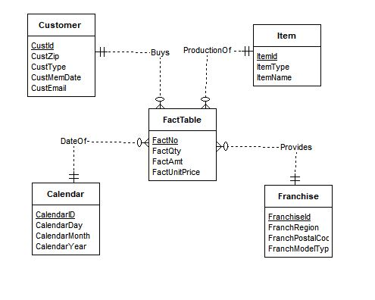

Q5.

Here are summarizability problems.

* Incomplete dimension-fact relationship for franchise: Spreadsheet lacks franchise information so additional data collection is required.
* The ERD and spreadsheet indicate that member type is incomplete for members. This problem can be resolved by default values for guests and corporate customers.
* Incomplete rollup for location dimension elements because zip codes in member table do not have city and state. The membership date applies only to members, not corporate customers and guests. There is no resolution for this incompleteness.

Q6.

Sample tables:

|  |  |  |  |
| --- | --- | --- | --- |
| ***Calendar*** | | | |
| *CalId* | *CalDay* | *CalMonth* | *CalYear* |
| 1111 | 10 | 2 | 2013 |
| 1112 | 11 | 2 | 2013 |
| 1113 | 12 | 2 | 2013 |
| 1114 | 13 | 2 | 2013 |
| 1115 | 14 | 2 | 2013 |
| 1116 | 15 | 2 | 2013 |
| 1117 | 16 | 2 | 2013 |

|  |  |  |
| --- | --- | --- |
| ***Item*** | | |
| *ItemId* | *ItemName* | *ItemType* |
| 1111 | Wilson balls | MRCH |
| 1112 | Wilson racket | MRCH |
| 1113 | Adidas shoes | MRCH |
| 1114 | Racket stringing | MRCH |
| 1115 | Ball machine | PASS |
| 1116 | Private lesson | PASS |
| 1117 | Adult class | PASS |

|  |  |  |  |
| --- | --- | --- | --- |
| **Franchise** | | | |
| *FranchId* | *FranchRegion* | *FranchPostalCode* | *FranchModelType* |
| 1111 | Northwest | 98011 | Full |
| 1112 | Mountain | 80111 | Medium |
| 1113 | Central | 45236 | Limited |

|  |  |  |  |  |  |
| --- | --- | --- | --- | --- | --- |
| **Customer** | | | | | |
| *CustId* | *CustName* | *CustZip* | *CustType* | *CustMemDate* | *CustEmail* |
| 1111 | Joe | 80111 | M1 | 1-Feb-2009 | joe@serv1.com |
| 2222 | Mary | 80113 | M2 | 1-Jan-2010 | mary@serv2.com |
| 3333 | Sue | 80114 | M3 | 3-Mar-2011 | sue@serv3.com |
| 4444 | George | 80112 | M4 |  | george@serv4.com |
| 5555 | Frist Data | 80111 | M5 |  |  |

|  |  |  |  |  |  |  |  |
| --- | --- | --- | --- | --- | --- | --- | --- |
| ***RevFact*** | | | | | | | |
| *RevFactNo* | *CustId* | *CalId* | *ItemId* | *FranchId* | *RevFactQty* | *RevFactAmt* | *RevFactUnitPrice* |
| 1 | 1111 | 1111 | 1111 | 1111 | 2 | $30 | $15 |
| 2 | 1111 | 1111 | 1112 | 1111 | 1 | $200 | $200 |
| 3 | 2222 | 1113 | 1114 | 1112 | 1 | $40 | $40 |
| 4 | 3333 | 1113 | 1113 | 1113 | 1 | $100 | $100 |
| 5 | 4444 | 1114 | 1114 | 1113 | 1 | $40 | $40 |
| 6 | 1111 | 1114 | 1114 | 1111 | 1 | $15 | $15 |
| 7 | 2222 | 1115 | 1116 | 1112 | 1 | $75 | $75 |